**Exercise 7**

Create the following time table in HTML with Dummy Data.

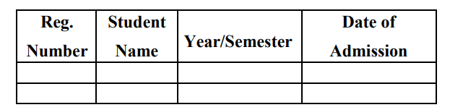

**Solution:-**

<html>

<head>

<title>Exercise 7</title>

</head>

<body bgcolor= #FFC0CB>

<h1 align="center" ><font color="Salmon">Timetable of BCA</font></h1><br>

<table align="center" border="2" cellspacing="0" cellpadding="15" bgcolor= #00FFFF>

<tr align="center" valign=="middle">

<th>DAY</th>

<th>I</th>

<th>II</th>

<th

rowspan="7"><b>T<br>E<br>A<br><br>B<br>R<br>E<br>A<br>K</b></th>

<th>III</th>

<th>IV</th>

<th

rowspan="7"><b>L<br>U<br>N<br>C<br>H<br><br>B<br>R<br>E<br>A<br>K</

b></th>

<th>V</th>

<th>VI</th>

<th>VII</th>

</tr>

<tr align="center">

<th>MON</th>

<td>IS</td>

<td>WT</td>

<td>SEM</td>

<td>OOAD</td>

<td>SCI</td>

<td>C#</td>

<td>COMP</td>

</tr>

<tr align="center">

<th>TUE</th>

<td>AP</td>

<td>AP Lab</td>

<td colspan="2">AP Lab</td>

<td>WT</td>

<td>IS</td>

<td>OOAD</td>

</tr>

<tr align="center">

<th>WED</th>

<td>WT</td>

<td>IS</td>

<td>C#</td>

<td>SCI</td>

<td colspan="3">MOOC'S</td>

</tr>

<tr align="center">

<th>THU</th>

<td>IS</td>

<td>LIB</td>

<td>OOAD</td>

<td>WT</td>

<td colspan="3">WT Lab</td>

</tr>

<tr align="center">

<th>FRI</th>

<td>AP</td>

<td>AP</td>

<td>C#</td>

<td>OOAD</td>

<td colspan="3">C# Lab</td>

</tr>

<tr align="center">

<th>SAT</th>

<td>OOAD</td>

<td>SCI</td>

<td>WT</td>

<td>SEM</td>

<td>AP</td>

<td>AP</td>

<td>C#</td>

</tr>

</table>

</body>

</html>

**Output:-**

